Module-2
Test Case Design Techniques and Defect management
Black Box Testing: Equivalence Class Partitioning, Boundary Value Analysis, Decision Tables;
White Box Testing: Statement, Branch, Path, and Cond
ition Coverage;
Defect Lifecycle, Bug Tracking Systems, Test Reporting.

Black-box techniques
Equivalence Partitioning
This black-box testing technique is also referred to as Equivalence Class Partitioning (ECP). This test case design technique is typically used to reduce the total number of test cases to a finite set of testable test cases, still covering maximum requirements.
In this method, the input domain data containing a range of input values is divided into different equivalence data classes (at times also referred to as split sets). Test cases should be written in such a way that they cover each equivalence partition (also called equivalence data class) at least once.
During test case execution, each value of every equivalence partition must display the same output behavior as the other one. This method is established on the assumption that if one condition/value in an equivalence partition passes, then all others will as well. Similarly, if one of the partition’s conditions fails, the partition’s other condition/value will likewise fail.
In short, it is the process of picking all possible test cases and carefully placing them into equivalence classes. One test value is picked from each class while testing.
This means a QA person tests a random value from each defined equivalence data class and if the verification of the output value is successful for that input value, then the entire equivalence class/partition is considered valid and vice versa.
Example #1: If you are testing for an input box accepting numbers from 1 to 1000, then there is no use in writing thousands of test cases for all 1000 valid input numbers plus other test cases for invalid data.
Using the Equivalence Partitioning method discussed above, test cases can be divided into three sets of input data, called equivalence data classes. Each test case is representative of the respective equivalence class.
So in the above example, we can divide our test cases into three equivalence classes of some valid and invalid input values.
Test cases for input box accepting numbers between 1 and 1000 using Equivalence Partitioning:
#1) Valid data test case (value between 1 and 1000): This includes one input data class with all valid inputs. Pick a single value from the range of 1 to 1000 (say 99) as a valid test case. If you select other values between 1 and 1000, then the result is going to be the same. So one test case for valid input data should be sufficient.
#2) Invalid data test case (value less than 1): Here, input data class with all values below the lower limit. i.e., any value below 1 (say zero), as an invalid input data test case.
#3) Invalid data test case (value greater than 1000): Input data with any value greater than 1000 (say 1001) to represent the invalid input class and the third equivalence class.
Example #2: Testing an input box for a mobile number accepting ten digits (i.e. length of input value has to be ten).
Again, the input value range can be divided into three equivalence data classes using the equivalence partitioning technique; one valid and two invalid classes.
Test cases for mobile number input box accepting ten digits:
#1) Valid data test case (= 10 digits): Enter the exact 10 digits, say 1234056789
#2) Invalid data test case (< 10 digits): Enter phone number with 9 digits, say 123456789
#3) Invalid data test case (> 10 digits): Enter phone number with 11 digits, say 12340567899
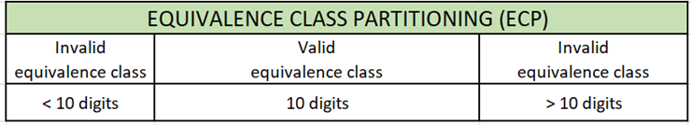
Partitioning by Equivalence
Equivalence Partitioning, also known as Equivalence Class Partitioning, is a black box testing approach that may be used at all stages of software development, including unit, integration, and system testing. Because of the minimal number of test cases, this approach divides input data units into comparable divisions that may be utilized to produce test cases, reducing the amount of time necessary for testing.
Example 1 − Boundary Value and Equivalence
Consider the Order Pizza Text Box's behavior. Pizza values ranging from 1 to 10 are deemed legitimate. The message "success" is shown.
While values 11 to 99 are deemed invalid for ordering, an error notice stating "Only 10 Pizza may be ordered" will show.
The test situation is as follows −
- Any number submitted in the Order Pizza form that is larger than 10 (let's say 11) is deemed invalid.
- Any number that is less than 1 and is 0 or below is deemed invalid.
- The numbers 1 to 10 are accepted as acceptable.
- Any three-digit number, such as -100, is unusable.

Test all of the potential values since it would result in more than 100 test cases. To solve this issue, we use the equivalence partitioning hypothesis, which divides the potential values of tickets into groups or sets, as illustrated below, where the system behavior is similar.
Equivalence Partitions or Equivalence Classes are the split sets. Then, for testing, we choose just one value from each split. This approach is based on the idea that if one condition/value in a partition passes, all others will as well. Similarly, if one condition in a partition fails, the partition's other criteria will also fail.
Equivalence Partitioning is divided into two sections
1. Pressman Rule − If the input consists of a range of numbers, create test cases for one valid and two incorrect values.
If the input consists of a collection of values, provide test cases for all legal value sets as well as two incorrect values.
Consider the following scenario −
Consider any online shopping website, where each product should be identified by a unique ID and name. Users may search for products using either the product name or the product ID. You may look at a list of items with product IDs and see whether any of them are Laptops (valid value).
Create test cases for both true and false values if the input is Boolean. Consider the following example web page, which has text fields for first name, last name, and email address, as well as radio buttons for gender that employ Boolean inputs.
The relevant value should be set as the input if the user clicks on any of the radio buttons. If the user selects a different choice, the input value must be changed to reflect the new selection (and the previously selected option should be deselected).
When a radio button option is selected, it is considered as TRUE, and when none is selected, it is treated as FALSE. Furthermore, two radio buttons should not be chosen at the same time; if they do, this is considered a problem.
2. Method of Practice − Divide the range of values into comparable portions for all of the valid values while also ensuring that two incorrect values are tested.
Advantages of equivalence partitioning
Equivalence partitioning requires more time than the selection of previously problematic values (i.e. historic values that led to defects).
- When applied correctly, it:
- forces the tester to execute detailed analysis of the input and output data characteristics and values;
- increases efficiency of tests by a reduction of the number of test cases;
- provides clear evidence concerning the sub-sets of data tested and how they were tested (via traceability from specifications to test conditions);
- helps identify forgotten cases;
- systematically increases the efficiency of tests to reduce the remaining risks.

Boundary Value Analysis
Boundary Value Analysis (BVA) is one of the widely used test case design techniques, as it is widely believed that the input values at the extreme ends (boundaries) of the input domain cause more errors in the system. These boundary values (extreme ends) could be maximum-minimum, lower-upper, start-end, just inside–just outside.
More application errors occur at the boundaries of the input domain, meaning more failures occur at lower and upper limit values of input data.
The ‘Boundary Value Analysis’ testing technique is used to identify errors at boundaries rather than finding those that exist in the center of the input domain. This kind of testing of boundary values (or boundaries) is also referred to as ‘boundary testing’.
The basic principle behind this technique is to choose input data values:
- Just below the minimum value
- Minimum value
- Just above the minimum value
- A Normal (nominal) value
- Just below the maximum value
- Maximum value
- Just above the maximum value
Boundary Value Analysis is the next part of Equivalence Partitioning for designing test cases where test cases are selected at the edges/boundaries of the equivalence classes. Test cases are designed to handle both valid and invalid boundary values which can give proper coverage.
Every equivalence class partition has its maximum and minimum values, which are called the boundary values of a partition.
- Valid boundary value refers to the boundary value of a valid equivalence partition.
- Invalid boundary value refers to the boundary value of an invalid equivalence partition.
Example #1: Test cases for input box accepting numbers between 1 and 1000 using Boundary value analysis:
#1) Test cases with test data exactly as the input boundaries of the input domain, i.e. values 1 and 1000 in our case.
#2) Test data with values just below the extreme edges of input domain, i.e. values 0 and 999.
#3) Test data with values just above the extreme edges of the input domain, i.e. values 2 and 1001.
Example #2: Input box (say for accepting age) accepts values between 21 and 55.
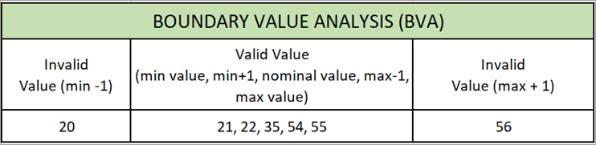
Valid input values: 21, 22, 35, 54, and 55
- Minimum boundary value: 21
- Maximum boundary value: 55
- Value at the center (nominal value): 35
Invalid input values: 20, 56
Test cases for input box accepting values between 21 and 55 using Boundary value analysis:
- Invalid value test case: Enter value = 20
- Valid value test case: Enter value = 21
- Valid value test case: Enter value = 22
- Valid value test case: Enter value = 35 (additional test case to check value almost at the center, also called nominal value)
- Valid value test case: Enter value = 54
- Valid value test case: Enter value = 55
- Invalid value test case: Enter value = 56
Example #3: Input box for the password accepts a minimum of 8 characters and a maximum of 14 characters (the length of input value should be in the range of 8 to 14).
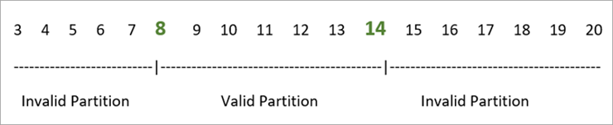
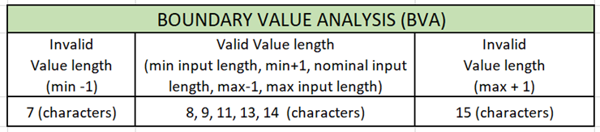
Valid input value length: 8, 9, 11, 13, and 14 characters
Invalid input value length: 7, 15 characters
Test cases for password input box accepting minimum 8 characters and maximum 14 characters using Boundary value analysis:
- Invalid input value length test case: Enter 7 characters
- Valid input value length test case: Enter 8 characters
- Valid input value length test case: Enter 9 characters
- Valid input value length test case: Enter 11 characters
- Valid input value length test case: Enter 13 characters
- Valid input value length test case: Enter 14 characters
- Invalid input value length test case: Enter 15 characters
Boundary Value Analysis is often referred to as part of Stress and Negative Testing.
Note: There is no hard-and-fast rule to test only one value from each equivalence class you created for input domains. You can select multiple valid and invalid values from each equivalence class according to your needs and previous judgments.
For instance, if you divide 1 to 1000 input values invalid data equivalence class, then you can select test case values like 1, 11, 100, 950, etc. The same is true for other test cases having invalid data classes.
Boundary Value Analysis VS Equivalence Class Partitioning
Equivalence Class Partitioning | Boundary Value Analysis
Valid & Invalid equivalence classes (ranges) of the input data domain are considered for test design & execution. | It considers the following for input data values:  • Minimum – 1  • Minimum  • Minimum + 1  • Nominal  • Maximum - 1  • Maximum  • Maximum + 1
It considers input data values from a range of equivalence classes (intervals) of the input data domain. | It considers input data values based on the defined boundaries of the input data domain.
It is significant in identifying bugs in-between the defined equivalence classes. | It is significant in identifying bugs at the boundaries of the input data domain.
It can be used at any stage of the testing process. | It is specifically used as part of stress and negative testing.
It is important to identify equivalence classes correctly to make effective use of this technique. | Determining correct boundary conditions plays a vital role in effectively using this technique.

Example: Equivalence and Boundary Value
Following password field accepts minimum 6 characters and maximum 10 characters
That means results for values in partitions 0-5, 6-10, 11-14 should be equivalent
Enter Password:
Test Scenario # | Test Scenario Description | Expected Outcome
1 | Enter 0 to 5 characters in password field | System should not accept
2 | Enter 6 to 10 characters in password field | System should accept
3 | Enter 11 to 14 character in password field | System should not accept

Examples: Input Box should accept the Number 1 to 10
Here we will see the Boundary Value Test Cases
Test Scenario Description | Expected Outcome
Boundary Value = 0 | System should NOT accept
Boundary Value = 1 | System should accept
Boundary Value = 2 | System should accept
Boundary Value = 9 | System should accept
Boundary Value = 10 | System should accept
Boundary Value = 11 | System should NOT accept
Advantages of boundary values
- Boundary value analysis is a technique that applies to all test levels and can require access to the code (for loops boundaries and variable types description).
- In general, boundary value analysis is executed after equivalence partitioning and applies to the values input via the application interfaces (both graphical and non-graphical interfaces).
- Values in the equivalence partitions are sorted to identify the upper and lower boundaries of these partitions.
- It is also possible to use this technique for nonfunctional, such as performances, load and stress.
Decision tables
Decision table testing is a software testing technique used to test system behavior for different input combinations. This is a systematic approach where the different input combinations and their corresponding system behavior (Output) are captured in a tabular form. That is why it is also called as a Cause-Effect table where Cause and effects are captured for better test coverage.
A Decision Table is a tabular representation of inputs versus rules/cases/test conditions. It is a very effective tool used for both complex software testing and requirements management. A decision table helps to check all possible combinations of conditions for testing and testers can also identify missed conditions easily. The conditions are indicated as True(T) and False(F) values.

Example 1: How to make Decision Base Table for Login Screen
Let’s create a decision table for a login screen.
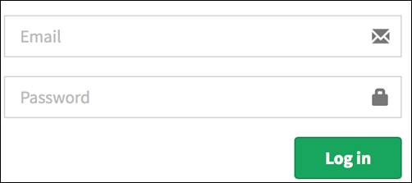
The condition is simple if the user provides the correct username and password the user will be redirected to the homepage. If any of the input is wrong, an error message will be displayed.
Conditions | Rule 1 | Rule 2 | Rule 3 | Rule 4
Username (T/F) | F | T | F | T
Password (T/F) | F | F | T | T
Output (E/H) | E | E | E | H
Legend:
- T – Correct username/password
- F – Wrong username/password
- E – Error message is displayed
- H – Home screen is displayed
Interpretation:
- Case 1 – Username and password both were wrong. The user is shown an error message.
- Case 2 – Username was correct, but the password was wrong. The user is shown an error message.
- Case 3 – Username was wrong, but the password was correct. The user is shown an error message.
- Case 4 – Username and password both were correct, and the user navigated to the homepage

While converting this to a test case, we can create 2 scenarios,
- Enter the correct username and correct password and click on login, and the expected result will be the user should be navigated to the homepage
And one from the below scenario
- Enter wrong username and wrong password and click on login, and the expected result will be the user should get an error message
- Enter correct username and wrong password and click on login, and the expected result will be the user should get an error message
- Enter wrong username and correct password and click on login, and the expected result will be the user should get an error message
As they essentially test the same rule.

Example 2: How to make Decision Table for Upload Screen
Now consider a dialogue box that will ask the user to upload a photo with certain conditions like –
- You can upload only ‘.jpg’ format image
- file size less than 32kb
- resolution 137*177.
If any of the conditions fails the system will throw a corresponding error message stating the issue and if all conditions are met photo will be updated successfully
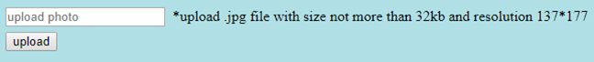Let’s create the decision table for this case.
Conditions | Case 1 | Case 2 | Case 3 | Case 4 | Case 5 | Case 6 | Case 7 | Case 8
Format | .jpg | .jpg | .jpg | .jpg | Not .jpg | Not .jpg | Not .jpg | Not .jpg
Size | Less than 32kb | Less than 32kb | >= 32kb | >= 32kb | Less than 32kb | Less than 32kb | >= 32kb | >= 32kb
resolution | 137*177 | Not 137*177 | 137*177 | Not 137*177 | 137*177 | Not 137*177 | 137*177 | Not 137*177
Output | Photo uploaded | Error message resolution mismatch | Error message size mismatch | Error message size and resolution mismatch | Error message for format mismatch | Error message format and resolution mismatch | Error message for format and size mismatch | Error message for format, size, and resolution mismatch
For this condition, we can create 8 different test cases and ensure complete coverage based on the above table.
- Upload a photo with format ‘.jpg’, size less than 32kb and resolution 137*177 and click on upload. Expected result is Photo should upload successfully
- Upload a photo with format ‘.jpg’, size less than 32kb and resolution not 137*177 and click on upload. Expected result is Error message resolution mismatch should be displayed
- Upload a photo with format ‘.jpg’, size more than 32kb and resolution 137*177 and click on upload. Expected result is Error message size mismatch should be displayed
- Upload a photo with format ‘.jpg’, size more than equal to 32kb and resolution not 137*177 and click on upload. Expected result is Error message size and resolution mismatch should be displayed
- Upload a photo with format other than ‘.jpg’, size less than 32kb and resolution 137*177 and click on upload. Expected result is Error message for format mismatch should be displayed
- Upload a photo with format other than ‘.jpg’, size less than 32kb and resolution not 137*177 and click on upload. Expected result is Error message format and resolution mismatch should be displayed
- Upload a photo with format other than ‘.jpg’, size more than 32kb and resolution 137*177 and click on upload. Expected result is Error message for format and size mismatch should be displayed
- Upload a photo with format other than ‘.jpg’, size more than 32kb and resolution not 137*177 and click on upload. Expected result is Error message for format, size and resolution mismatch should be displayed.
Advantages of Decision Table Testing
- When the system behavior is different for different inputs and not the same for a range of inputs, both equivalent partitioning, and boundary value analysis won’t help, but a decision table can be used.
- The representation is simple so that it can be easily interpreted and is used for development and business as well.
- This table will help to make effective combinations and can ensure better coverage for testing
- Any complex business conditions can be easily turned into decision tables
- In a case we are going for 100% coverage typically when the input combinations are low, this technique can ensure the coverage.

Disadvantages of Decision Table Testing
- The main disadvantage is that when the number of inputs increases the table will become more complex.
White box testing
Statement testing and coverage
Statement Coverage Testing
The statement coverage technique is used to design test cases for white box testing which involves the execution of all the statements of the source code at least once. This article focuses on discussing statement coverage in detail.
What is Statement Coverage?
It is one type of white box testing technique that ensures that all the statements of the source code are executed at least once. It covers all the paths, lines, and statements of a source code. It is used to design test box cases where it will find out the total number of executed statements out of the total statements present in the code.
Formula:
Statement coverage = (Number of executed statements / Total number of statements in source code) * 100
Example 1:
Read A
Read B
if A > B
Print “A is greater than B”
else
Print "B is greater than A"
endif
Case 1:
If A = 7, B= 3
No of statements Executed= 5
Total statements= 7
Statement coverage= 5 / 7 * 100
= 71.00 %

Case 2:
If A = 4, B= 8
No of statements Executed= 6
Total statements= 7
Statement coverage= 6 / 7 * 100
= 85.20 %
Example 2:
print (int a, int b)
{
int sum = a + b;
if (sum > 0)
print ("Result is positive”)
else
print ("Result is negative”)
}
Case 1:
If A = 4, B= 8
No of statements Executed= 6
Total statements= 8
Statement coverage= 6 / 8 * 100
= 75.00 %
Case 2:
If A = 4, B= -8
No of statements Executed= 7
Total statements= 8
Statement coverage= 7 / 8 * 100
= 87.50 %
In the internal code structure, there are loops, arrays, methods, exceptions, and control statements. Some code would be executed based on input while some may not. Statement coverage will execute all possible paths and statements of the code

Let’s understand this with an some more example, how to calculate statement coverage.
Scenario to calculate Statement Coverage for given source code. Here we are taking two different scenarios to check the percentage of statement coverage for each scenario.
Source Code:
Prints (int a, int b) { ------------ Print sum is a function
int result = a+ b;
If (result> 0)
Print ("Positive", result)
Else
Print ("Negative", result)
} ----------- End of the source code
Scenario 1:
If A = 3, B = 9
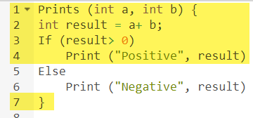
The statements marked in yellow color are those which are executed as per the scenario
Number of executed statements = 5, Total number of statements = 7
Statement Coverage: 5/7 = 71%
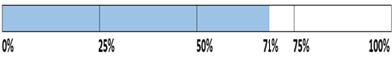

Likewise we will see scenario 2,
Scenario 2:
If A = -3, B = -9
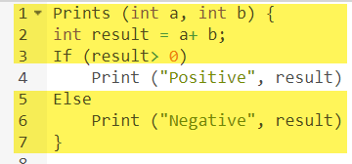
The statements marked in yellow color are those which are executed as per the scenario.
Number of executed statements = 6
Total number of statements = 7
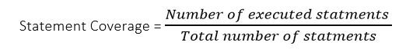
Statement Coverage: 6/7 = 85%
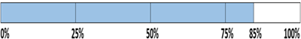
But overall if you see, all the statements are being covered by both scenarios. So we can conclude that overall statement coverage is 100%.
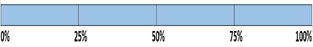
What is covered by Statement Coverage?
- Unused Statements
- Dead Code
- Unused Branches
- Missing Statements

Statement coverage covers:
- Dead code.
- Unused statements.
- Unused branches.
- Missing statements.

Why is statement coverage used?
- To check the quality of the code.
- To determine the flow of different paths of the program.
- Check whether the source code expected to perform is valid or not.
- tests the software’s internal coding and infrastructure.
Drawback of Statement Coverage:
- Cannot check the false condition.
- Different input values to check all the conditions.
- More than one test case may be required to cover all the paths with a coverage of 100%.

Branch
- Branch Testing and branch Testing Ensuring Code Reliability
- Branch Testing is a technique in software testing that ensures all control flow branches in a program are tested. These branches include both conditional (e.g., if-else) and unconditional paths (e.g., sequential execution).
Key Concepts
- Branch Coverage Formula:
Branch Coverage (%) = (Number of Executed Branches / Total Branches) × 100
- Objectives:
- Ensure each decision point (e.g., if, switch, loops) evaluates to all possible outcomes at least once.
- Validate both true and false outcomes for conditional branches.
3. 100% Branch Coverage:
- Ensures all branches are executed by test cases.
- Guarantees 100% statement coverage (but not the other way around).
Benefits of Branch Testing
- Detects missing branches or conditions.
- Provides better control flow testing than statement coverage.
- Improves reliability of code by covering all decision outcomes.
Limitations
- Does not test specific paths or combinations of branches.
- May still miss defects that depend on a sequence of branch executions.

Example-1
Consider the following code:
if (x > 0):
print("Positive")
else:
print("non-positive")
print("Done")
Branches:
- if (x > 0) → True
- if (x > 0) → False
Test Cases for 100% Branch Coverage:
- Test Case 1: x = 5 → True branch executed.
- Test Case 2: x = -3 → False branch executed.
Result: Both branches are tested, achieving 100% branch coverage.
Main idea:
- Branch testing is essential for ensuring code correctness, especially in decision-heavy logic.
- By subsuming statement coverage, it offers more robust test coverage.
Example 1: Nested If-Else
def categorize _number(x):
if x > 0:
if x % 2 == 0:
print("Positive Even")
else:
print("Positive Odd")
else:
print("Non-positive")
Branches:
- if x > 0 → True
- if x > 0 → False
- if x % 2 == 0 (Only evaluated when x > 0) → True
- if x % 2 == 0 → False
Test Cases for 100% Branch Coverage:
- x = 4 → Positive Even
- x = 5 → Positive Odd
- x = -1 → non-positive
Example 2: If-Elif-Else
def check_grade(score):
if score >= 90:
print("A")
elif score >= 75:
print("B")
else:
print("C")
Branches:
- if score >= 90 → True
- if score >= 90 → False → elif score >= 75 → True
- if score >= 90 → False → elif score >= 75 → False
Test Cases:
- score = 92 → A
- score = 80 → B
- score = 60 → C
Example 3: Loop with If Condition
def count_positives(numbers):
count = 0
for n in numbers:
if n > 0:
count += 1
return count
Branches:
- Loop executes at least once
- if n > 0 → True
- if n > 0 → False
- Loop doesn’t execute (empty list)
Test Cases:
- [1, -2, 3] → True and False conditions within loop
- [] → Loop doesn't run (edge case)
- [-1, -2] → Only False branch of if
Example 4: Multiple Conditions (AND operator)
def is_eligible(age, has_id):
if age >= 18 and has_id:
return "Allowed"
else:
return "Not Allowed"
Branches:
- Condition evaluates True (age ≥ 18 and has_id = True)
- Condition evaluates False (any one condition fails)

Test Cases:
- age = 20, has_id = True → Allowed
- age = 17, has_id = True → Not Allowed
- age = 20, has_id = False → Not Allowed

Path
What is Path Testing in Software Testing?
Path testing is a structural testing method that involves using the source code of a program in order to find every possible executable path. It helps to determine all faults lying within a piece of code. This method is designed to execute all or selected path through a computer program.
Any software program includes, multiple entry and exit points. Testing each of these points is a challenging as well as time-consuming. In order to reduce the redundant tests and to achieve maximum test coverage, basis path testing is used.
Basis Path Testing in Software Engineering
Basis Path Testing in software engineering is a White Box Testing method in which test cases are defined based on flows or logical paths that can be taken through the program. The objective of basis path testing is to define the number of independent paths, so the number of test cases needed can be defined explicitly to maximize test coverage.
In software engineering, Basis path testing involves execution of all possible blocks in a program and achieves maximum path coverage with the least number of test cases. It is a hybrid method of branch testing and path testing methods.
Here we will take a simple example, to get a better idea what is basis path testing include
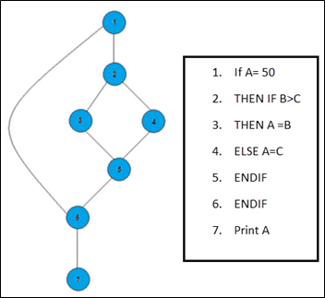
In the above example, we can see there are few conditional statements that is executed depending on what condition it suffice. Here there are 3 paths or condition that need to be tested to get the output,
- Path 1: 1,2,3,5,6, 7
- Path 2: 1,2,4,5,6, 7
- Path 3: 1, 6, 7
Steps for Basis Path testing
The basic steps involved in basis path testing include
- Draw a control graph (to determine different program paths)
- Calculate Cyclomatic complexity (metrics to determine the number of independent paths)
- Find a basis set of paths
- Generate test cases to exercise each path
Advantages of Basic Path Testing
- It helps to reduce the redundant tests
- It focuses attention on program logic
- It helps facilitates analytical versus arbitrary case design
- Test cases which exercise basis set will execute every statement in a program at least once

Path Testing & Basis Path Testing with Example
Basis Path Testing is a white-box testing technique based on a program's or module's control structure. A control flow graph is created using this structure, and the many possible paths in the graph are tested using this structure.
The approach of identifying pathways in the control flow graph that give a foundation set of execution paths through the program or module is known as basis path testing.
Because this testing is dependent on the program's control structure, it necessitates a thorough understanding of the program's structure.
Four stages are followed to create test cases using this technique −
- Create a Control Flow Graph.
- Calculate the Graph's Cyclomatic Complexity
- Identify the Paths That Aren't Connected
- Create test cases based on independent paths.
1. Control Flow Graph
A control flow graph (or simply flow graph) is a directed graph that depicts a program's or module's control structure. V number of nodes/vertices and E number of edges make up a control flow graph (V, E). A control graph can also include the following −
- A node with multiple arrows entering it is known as a junction node.
- A node having more than one arrow leaving it is called a decision node.
- The area encompassed by edges and nodes is referred to as a region (area outside the graph is also counted as a region.).
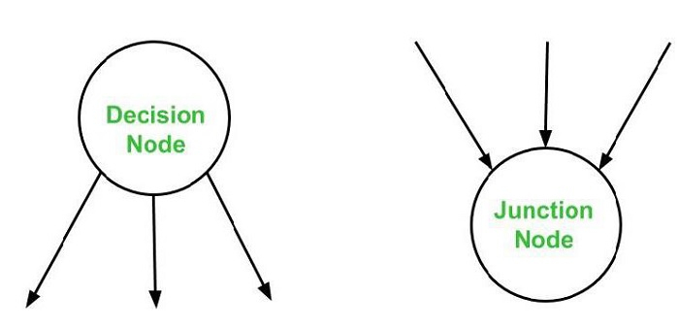
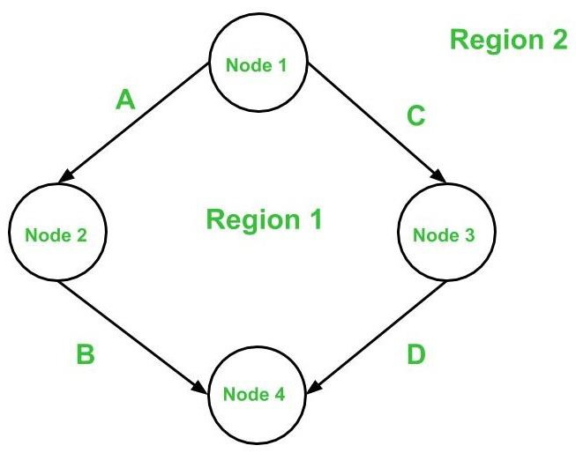
Below are the notations utilized while constructing a flow graph −
- Sequential Statements –
- Represents a linear sequence of statements executed one after another without branching. In the CFG, each statement is a node, and edges connect them in execution order (e.g., Statement1 → Statement2).
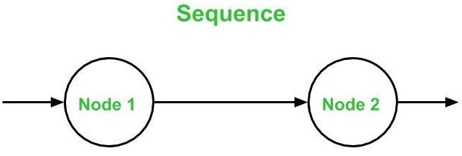
- If – Then – Else
- Represents a conditional statement with two possible paths: one for the "then" branch (if the condition is true) and one for the "else" branch (if false). The decision node (condition) has two outgoing edges to separate nodes for each branch, which may converge at a junction node.
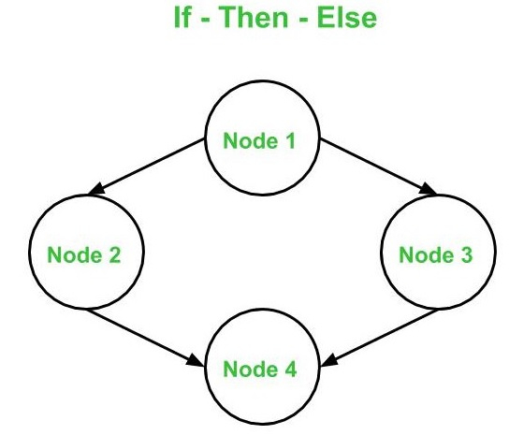
- Do – While
- Represents a loop where a block of statements is executed at least once, followed by a condition check. The CFG has a loop with a decision node at the end (condition) with one edge looping back to the start of the block and another exiting the loop.
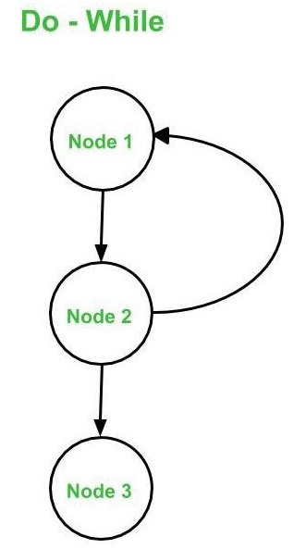
- While – Do
- Represents a loop where a condition is checked before executing a block of statements. The CFG starts with a decision node (condition) with one edge to the statement block (if true) and another to exit the loop (if false), with a loop-back edge from the block to the condition.
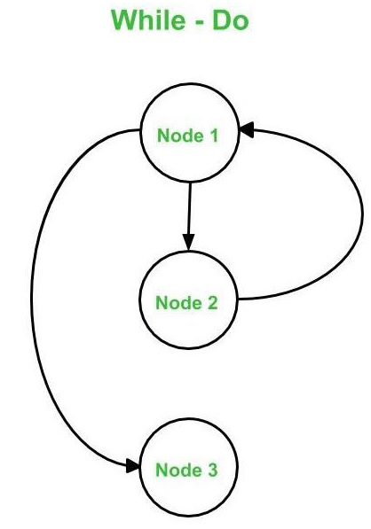
- Switch – Case
- Represents a multi-way branching structure where a variable is evaluated, and control jumps to one of several case blocks. The CFG has a decision node (switch expression) with multiple outgoing edges, each leading to a case block, and possibly a default branch, converging at a junction node.
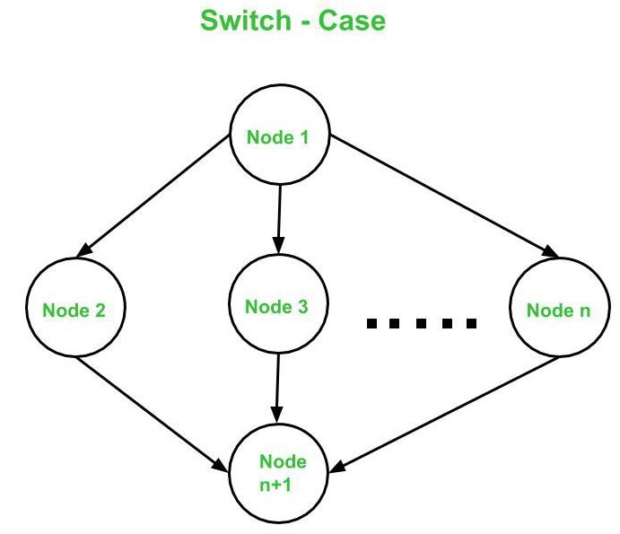

2. Compute Cyclomatic Complexity
Cyclomatic Complexity
The cyclomatic complexity V(G) is said to be a metric for a program's logical complexity.
Three distinct formulas can be used to compute it −
V(G) = e - n + 2*P is a formula based on edges and nodes.
Where e is the number of edges, n denotes the number of vertices, and P denotes the number of connected components.
Take, for example, the first graph shown above.
where e = 4, n = 4, and p = 1 are all integers
V(G) = 4 - 4 + 2 * 1 = 2 cyclomatic complexity
Formula based on Regions :
The following is a formula based on Decision Nodes −
V(G) = d + P, where d represents the number of decision nodes and P represents the number of connected nodes.
Take, for example, the first graph shown above.
where d=1 and p=1
V(G) = 1 + 1 = 2 cyclomatic complexity
The following is a formula based on regions −
V(G) denotes the number of graph regions.
Take, for example, the first graph shown above.
V(G) = 1 (for region 1) + 1 (for region 2) = 2 cyclomatic complexity
As a result, the cyclomatic complexity derived using all three formulas remains the same. These three equations can be used to compute and validate the flow graph's cyclomatic complexity.
Observation
Only one flow graph is created for each function [e.g. Main( ) or Factorial() ]. If there are many functions in a program, a separate flow graph is created for each of them. In addition, the value of ‘p' in the cyclomatic complexity formula is determined by the total number of graphs.
If there are exactly two arrows leaving a decision node, it is counted as one decision node. If there are more than two arrows leaving a decision node, the following formula is used −
d = k - 1
The number of arrows leaving the decision node is given by k.
Independent Path
In the control flow graph, an independent path is one that introduces at least one new edge that has not been traversed before the path is created. The cyclomatic complexity of a flow graph is the number of independent pathways present. This is because the cyclomatic complexity is used as an upper limit for the number of tests that should be run to ensure that all of the program's statements have been run at least once.
In the first graph, the number of independent paths is equal to the cyclomatic complexity, hence the number of independent paths is 2.
So, in the above-mentioned first graph, the independent pathways are −
- A -> B is the first path.
- C -> Dis the second path.
Note − It's worth noting that independent paths aren't necessarily unique. In other words, if the cyclomatic complexity of a graph is N, there is a chance of finding two distinct sets of pathways, each of which is independent in nature.
Finally, once the separate paths have been obtained, test cases can be constructed, with each test case representing one or more independent paths.
Examples of Path Testing
In the previous post, we looked at the stages involved in creating test cases for a program utilizing base path testing. Let's now solve an example using the same steps.
Consider the following program, which determines whether an integer is prime or not. The following is the schedule for the following program −
- Create a Control Flow Diagram.
- Calculate the cyclic complexity using all of the methods available.
- Create a list of all the Independent Paths Design test cases.
int main (){
int n, index;
cout << "Enter a number: " << endl;
cin >> n;
index = 2;
while (index <= n - 1) {
if (n % index == 0) {
cout << "It is not a prime number" << endl;
break;
}
index++;
}
if (index == n)
cout << "It is a prime number" << endl;
} // end main
Solution: 1. Create a Control Flow Diagram
Step 1 − After declaring the variables, begin numbering the statements (if no variables have been initialized in that statement). If a variable is initialized and declared on the same line, however, the numbering should begin on that line.
This is how numbering will be done for the supplied program −
int main (){
int n, index;
cout << "Enter a number: " <> n;
index = 2;
while (index <= n - 1){
if (n % index == 0){
cout << "It is not a prime number" << endl;
break;
}
index++;
}
if (index == n)
cout << "It is a prime number" << endl;
} // end main
Step 2 − Combine all of the sequential statements into one node. Statements 1, 2, and 3 are, for example, all consecutive statements that should be concatenated into a single node. For the rest of the statements, we'll use the notations described here.
Note − To keep things simple, number nodes in alphabetical order.
The resulting graph will look like this −
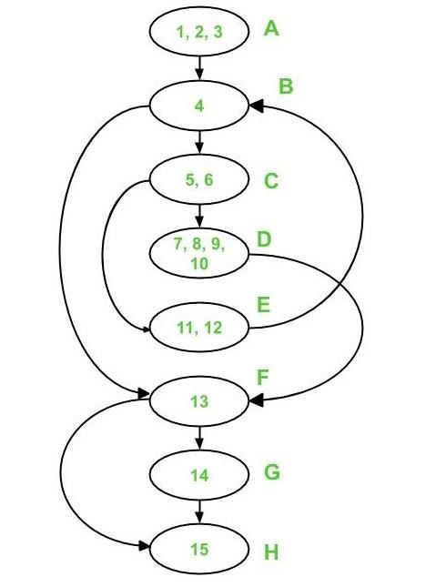
Calculate the cyclomatic complexity by using the following formula −
Method 1:
V(G) = e - n + 2*p
In the control flow diagram above,
where e = 10, n = 8, and p =1
As a result, V(G) = 10 - 8 + 2 * 1 = 4 Cyclomatic Complexity
Method 2:
V(G) = d + p
In the control flow diagram above,
where d = 3 (Node B, C, and F) and p = 1
As a result, the cyclomatic complexity V(G) = 3 + 1 = 4
Method 3:
V(G) = Number of Regions (method 3)
There are four zones in the aforementioned control flow graph, as indicated below −
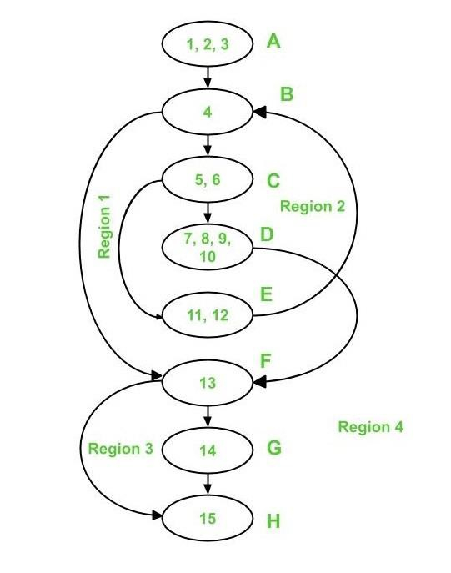
As a result, there are four distinct regions: R1, R2, R3, and R4.
V(G) = 1 + 1 + 1 + 1 = 4 cyclomatic complexity
It's worth noting that all three ways get the same cyclomatic complexity V value (G).
Independent Paths
Because the cyclomatic complexity V(G) for the graph is 4, there are 4 independent paths.
Path 1 covers (in red) the following edges −
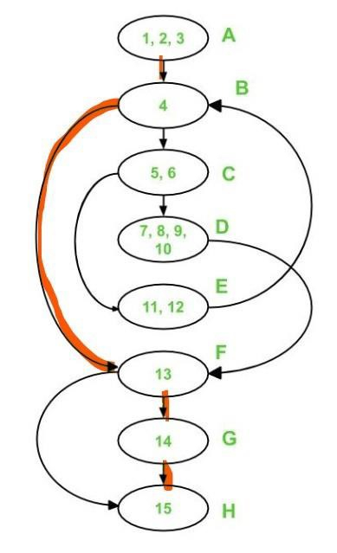
A – B – F – G – H is the first path.
The following are the edges that Path 1 and Path 2 cover −
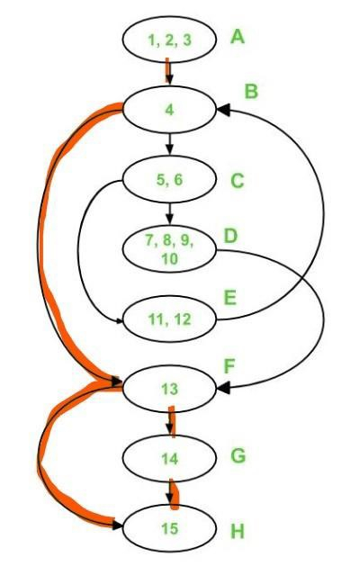
A – B – F – H is the second path.
Path 1, Path 2, and Path 3 cover the following edges −
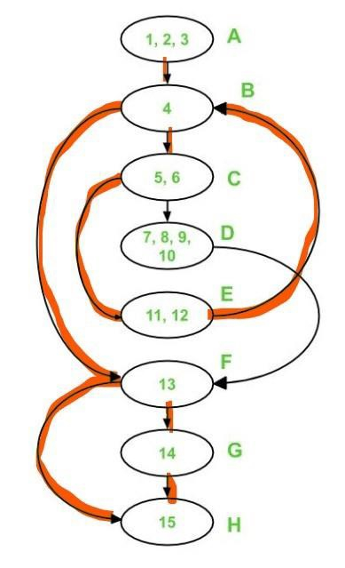
A - B - C - E - B - F - G - H is the third path
Only two edges remain uncovered, namely edge C-D and edge D-F. As a result, these two edges must be included in Path 4.
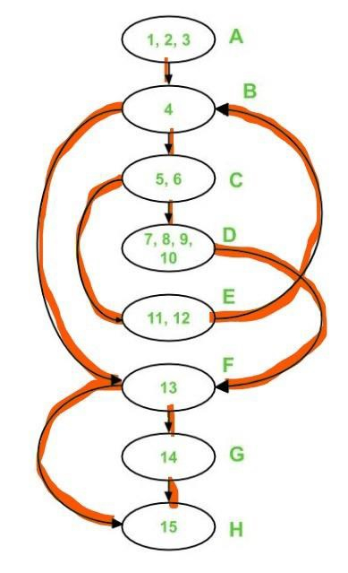
A - B - C - D - F - H is the fourth path.
Each of these pathways has at least one new edge that has never been crossed previously.
Note that independent pathways aren't always unique.
Test Cases
We must use the previously discovered independent paths to generate test cases. Provide input to the program in such a way that each independent path is executed to create a test case.
The following test cases will be obtained for the supplied program −
Test case ID | Input Number | Output | Independent Path covered
1 | 1 | No output | A-B-F-H
2 | 2 | It is a prime number | A-B-F-G-H
3 | 3 | It is a prime number | A-B-C-E-B-F-G-H
4 | 4 | It is not a prime number | A-B-C-D-F-H
Advantages of Basis Path Testing
Basis Path Testing is useful in the following situations −
- Additional Coverage − Because it focuses on maximum logic coverage rather than maximal path coverage, basis path testing gives the best code coverage. As a result, the code is well tested overall.
- Testing for Maintenance − When a piece of software is modified, it's still required to test the changes made, which necessitates path testing.
Advantages of Basis Path Testing
- Basis path testing provides the best code coverage as it aims to achieve maximum logic coverage instead of maximum path coverage. This results in an overall thorough testing of the code.
- When a software is modified, it is still necessary to test the changes made in the software which as a result, requires path testing.
- When a developer writes the code, he or she tests the structure of the program or module themselves first. This is why basis path testing requires enough knowledge about the structure of the code.
- When one module calls other modules, there are high chances of Interface errors. In order to avoid the case of such errors, path testing is performed to test all the paths on the interfaces of the modules.
- Since the basis path testing technique takes into account the complexity of the software (i.e., program or module) while computing the cyclomatic complexity, therefore it is intuitive to note that testing effort in case of basis path testing is directly proportional to the complexity of the software or program.
Disadvantages of Basis Path Testing
- High cyclomatic complexity requires numerous test cases, increasing effort.
- Focuses on logical paths, potentially missing data-related or integration issues.
- It demands detailed understanding of the codebase.
- Must be combined with other testing types.

Condition Coverage
What is Software Condition Coverage Testing?
The software condition coverage testing is a part of the white box testing. It is used by the developers to design white box test cases. It is primarily focused on covering all the conditions in the program source code. It is also referred to as predicate coverage testing.
In the software condition coverage testing every Boolean expression described in the conditions expression is evaluated to both true and false outcomes. As a result, it ensures that both the branches in a decision statement are tested. In case, a decision statement comprises various conditions namely OR, and AND, the condition coverage testing confirms that all the various combinations of the conditions are included in the test cases.
Formula to Calculate the Software Condition Coverage Percentage
The software condition coverage can be calculated by dividing the total count of conditions executed with the total count of conditions in the source code, and then multiplied by hundred.
Condition Coverage = (Total count of conditions executed / Total count of conditions in the source code) * 100

Why is Software Condition Coverage Testing Required?
The software condition coverage testing is required to ensure that the program source code is working properly, and is able to satisfy the given requirements. It is observed that the traditional testing methodologies sometimes miss particular paths in the code, thereby some of the critical defects remain undetected. The software condition coverage testing takes care of these situations by methodically verifying all the conditions inside the decision points. Thus it improves the overall quality, and performance of the software.
How is Software Condition Coverage Testing Performed?
The software condition coverage testing are performed by following the steps listed below −
Step 1 − Determine the decision points or conditional statements in the program source code like the if, else if, if, switch etc.
Step 2 − Every decision point may consist of more than one condition. These conditions are evaluated, and split into simpler modules to have an exhaustive testing.
Step 3 − Design test cases to include every possible result of all the conditions namely true, and false. It helps to cover every branch of code at the time of testing.
Step 4 − Execute the white box test cases, and evaluate the results. A coverage report is generated to measure the extent of verification of the conditions. It also describes the validated, and invalidated conditions, thereby it gives an idea if more fine tuning of the test cases are needed.
Advantages of Software Condition Coverage Testing
The advantages of the software condition coverage testing are listed below −
- The software condition coverage testing guarantees that all the conditions in the code are checked at least once.
- The software condition coverage testing detects defects from the early stages of the software development life cycle(SDLC).
- The condition coverage testing improves the quality, maintainability, and reliability of the software.
- The software condition coverage testing helps in faster troubleshooting of errors in the code.
- The condition coverage testing gives higher confidence, and trust on the code developed for the software.
Example:1
Let us take an example of the below code snippet to determine the count of the condition coverage.
Input X, Y, Z, and W
IF (X == 0 || Y == 0)
THEN PRINT 100
ELSE IF (Z == 0 && W == 0)
THEN PRINT 200
END IF
END
Let us now calculate the condition coverage with the first test case, with the inputs X = 0, Y = 0, Z = 0, W = 0. With these values, the first condition of the OR operator with the expression X == 0, holds true. Since the result of the left side of the OR is already true, so the right side of the expression, Y == 0 of it, will be skipped from evaluation.
So, the condition Y == 0 remained unchecked. Then, the statement 3 will be executed resulting in printing 100 and the condition IF (Z == 0 && W == 0) in the ELSE part(at the line 4) will not be executed. Hence, out of a total four conditions, only one of them got executed. The total condition coverage as per formula:
Condition Coverage = (Total count of conditions executed / Total count of conditions in the source code) * 100 Condition Coverage = (1 / 4) * 100 = 25 %.

Let us now calculate the condition coverage with the second test case, with the inputs X = 1, Y = 0, Z = 0, W = 0. With these values, the first condition having the OR operator with the expression X == 1, holds false. As the result of the left side of the OR is false, so the right side expression Y == 0 of it, will be evaluated. So this time, the condition Y == 0 is checked. Then, the statement 3 will be executed resulting in printing 100 and the condition IF (Z == 0 && W == 0) in the ELSE part(at the line 4) will remain unchecked. Hence, out of a total four conditions, two of them got executed. The total condition coverage as per formula
Condition Coverage = (Total count of conditions executed / Total count of conditions in the source code) * 100 Condition Coverage = (2 / 4) * 100 = 50 %

Let us now calculate the condition coverage with the third test case, with the inputs X = 1, Y = 1, Z = 0, W = 0. With these values, the first condition having the OR operator with the expression X == 1, holds false. As the left side of the OR is false, so the right side expression Y == 1 of it, will be evaluated. Since both sides of the OR operator result in false, so this time, the condition IF (Z == 0 && W == 0) in the ELSE part(at the line 4) will be executed.
The first condition having the AND operator with the expression Z == 0, holds true. Though the left side of the AND operator is true, the right side expression W == 0 will also need to be evaluated. Since both of them are true, then, the statement 5 will be executed resulting in printing 200. Hence, out of total four conditions, four of them got executed this time. The total condition coverage as per formula
Condition Coverage = (Total count of conditions executed / Total count of conditions in the source code) * 100 Condition Coverage = (4 / 4) * 100 = 100 %.
Defect Lifecycle
What is Defect/Bug Life Cycle?
Defect Life Cycle or Bug Life Cycle in software testing is the specific set of states that defect or bug goes through in its entire life. The purpose of Defect life cycle is to easily coordinate and communicate current status of defect which changes to various assignees and make the defect fixing process systematic and efficient.
Defect Status
Defect Status or Bug Status in defect life cycle is the present state from which the defect or a bug is currently undergoing. The goal of defect status is to precisely convey the current state or progress of a defect or bug in order to better track and understand the actual progress of the defect life cycle.
Defect States Workflow
The number of states that a defect goes through varies from project to project. Below lifecycle diagram, covers all possible states
- New: When a new defect is logged and posted for the first time. It is assigned a status as NEW.
- Assigned: Once the bug is posted by the tester, the lead of the tester approves the bug and assigns the bug to the developer team
- Open: The developer starts analyzing and works on the defect fix
- Fixed: When a developer makes a necessary code change and verifies the change, he or she can make bug status as “Fixed.”
- Pending retest: Once the defect is fixed the developer gives a particular code for retesting the code to the tester. Since the software testing remains pending from the testers end, the status assigned is “pending retest.”
- Retest: Tester does the retesting of the code at this stage to check whether the defect is fixed by the developer or not and changes the status to “Re-test.”
- Verified: The tester re-tests the bug after it got fixed by the developer. If there is no bug detected in the software, then the bug is fixed and the status assigned is “verified.”
- Reopen: If the bug persists even after the developer has fixed the bug, the tester changes the status to “reopened”. Once again the bug goes through the life cycle.
- Closed: If the bug is no longer exists then tester assigns the status “Closed.”
- Duplicate: If the defect is repeated twice or the defect corresponds to the same concept of the bug, the status is changed to “duplicate.”
- Rejected: If the developer feels the defect is not a genuine defect then it changes the defect to “rejected.”
- Deferred: If the present bug is not of a prime priority and if it is expected to get fixed in the next release, then status “Deferred” is assigned to such bugs
- Not a bug: If it does not affect the functionality of the application then the status assigned to a bug is “Not a bug”.

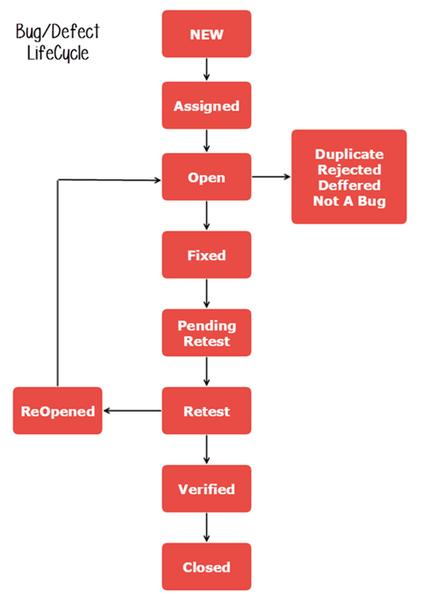
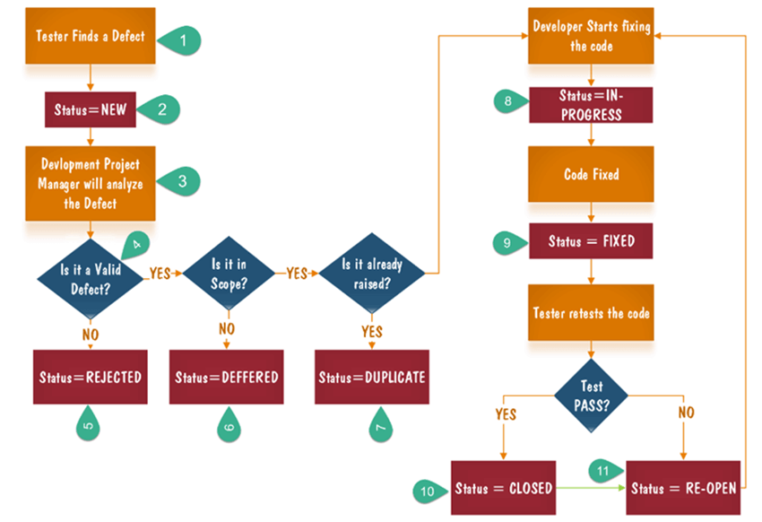

- Tester finds the defect
- Status assigned to defect- New
- A defect is forwarded to Project Manager for analyze
- Project Manager decides whether a defect is valid
- Here the defect is not valid- a status is given “Rejected.”
- So, project manager assigns a status rejected. If the defect is not rejected then the next step is to check whether it is in scope. Suppose we have another function- email functionality for the same application, and you find a problem with that. But it is not a part of the current release when such defects are assigned as a postponed or deferred status.
- Next, the manager verifies whether a similar defect was raised earlier. If yes defect is assigned a status duplicate.
- If no the defect is assigned to the developer who starts fixing the code. During this stage, the defect is assigned a status in- progress.
- Once the code is fixed. A defect is assigned a status fixed
- Next, the tester will re-test the code. In case, the Test Case passes the defect is closed. If the test cases fail again, the defect is re-opened and assigned to the developer.
- Consider a situation where during the 1st release of Flight Reservation a defect was found in Fax order that was fixed and assigned a status closed. During the second upgrade release the same defect again re-surfaced. In such cases, a closed defect will be re-opened.
Bug Tracking Systems
What is Defect Tracking?
Defect tracking, aka Bug tracking, is the systematic process of identifying, recording, monitoring, and managing defects or issues in a product or system throughout its development lifecycle. These defects can encompass various aspects, including software bugs, hardware malfunctions, design flaws, or other imperfections that may hinder the product’s functionality, performance, or quality.
Why is Defect Tracking Required?
A defect tracker is like a digital journal that records all the problems or errors in a product or project. It’s like having a list of everything that’s not working correctly.
Here’s why it’s important and how it works:
- Preventing Errors from Being Missed: Imagine you’re building a house, and there are many different parts to it—plumbing, electrical, walls, and so on. If you don’t keep a list of every issue you discover (like a leaky faucet or a cracked wall), you might forget to fix some of them. A defect tracker is like that list; it ensures that every problem, or “defect,” is written down so that none of them are missed.
- Saving Time: When building something or creating a project, you want to avoid checking the same things repeatedly. That’s not only frustrating but also a waste of time. A defect tracker helps with this by tracking what issues have already been fixed. It’s like putting a checkmark next to a problem once it’s solved. This way, you don’t have to keep looking at the same issues, and you can focus on what still needs to be fixed.
- Working on the Right Problems: Sometimes, there are so many issues that it can be overwhelming. Imagine you have a pile of homework and need help figuring out where to start.
A defect tracker helps you decide what’s most important. It can categorize the problems based on how severe they are. For example, a major issue like a broken door is more important to fix than a small scratch on the wall. So, it helps ensure that the correct problems are being worked on first.
Who Needs Defect Tracking?
1. Development Teams: To find, log, and eventually root out bugs in software as it is being built.
2. Quality Assurance (QA) Teams: An assurance that all identified defects will be logged and that these will be prioritized and addressed before the software is released.
3. Project Managers: To keep an eye on defects being fixed and also that in process quality standards are met.
4. Product Owners: Because they have to track defect trends plus make sure any critical items are prioritized in accordance with business impact.
5. Support Teams: To handle and track defects reported by end-users and provide solutions or workarounds.
Objectives of Defect Tracking
Here are some objectives :
- Keeping Track of All Defects: Imagine you have a notebook where you write down every mistake you find in your homework. Bug tracking is like that notebook for software. It ensures that every little error or “defect” is written down so none are forgotten. This is super important because missing a defect could cause problems later when people use the software.
- Finding the Best Solutions and Preventing More Defects: Once you’ve written down all the defects, it’s like having a list of things to fix. But it’s not just about setting them; it’s also about figuring out the best way. Think of it as having a guide telling you the smartest way to solve a problem. Plus, it helps you learn from your mistakes and prevent similar issues from happening again. It’s like learning not to spill your juice after you’ve cleaned up a spill once.
- Saving Time and Doing Better Work: Imagine you’re building a puzzle. If you keep looking for the same piece repeatedly, it will take forever to finish the puzzle. Defect tracking ensures you don’t waste time looking at the same problems repeatedly. It’s like having a helper who says, “You’ve already solved that part; now let’s work on the parts that still need fixing.” This saves time and helps you do a better job because you can focus on what’s most important.
Tracking software defects saves time and improves quality. It’s like having a superhero assistant to find solutions and avoid repeating mistakes. Get superpowers for better software!
Defect Tracking Key Features
Here are some key features listed below:
- Effective communication: Defect tracking is a team effort, so it is essential to have effective communication between all stakeholders. This includes the developers, testers, and managers.
- Proper documentation: All defects should be properly documented, including the steps to reproduce the defect, the severity of the defect, and the impact of the defect. This documentation will help the developers to fix the defects quickly and efficiently.
- Regular reporting: Tracking should be a continuous process. Regularly reporting defects’ status will help identify any trends or patterns. This information can be used to improve the defect tracking process and to prevent defects from occurring in the future.
- Prioritization: Not all defects are created equal. Some defects are more critical than others. It is essential to prioritize defects so that the most critical defects are fixed first.
- Tracking of defects: It is important to track the progress of defects. This includes tracking the status of the defect, the assigned engineer, and the estimated time to fix the defect. This tracking information will help to ensure that defects are fixed on time.
- Resolution of defects: The goal of is to resolve defects. This means that the defect should be fixed, and the fix should be verified.
- Continuous improvement: Tracking is an ongoing process. It is essential to improve the defect-tracking process continuously. This can be done by identifying and addressing gaps or weaknesses in the process.
Defect Tracking Parameters
The parameters are the attributes that are used to track defects. These parameters can be used to identify, prioritize, and manage defects.
Some of the common defect-tracking parameters include:
- ID: A unique identifier for each defect.
- Title: A brief description of the defect.
- Description: A precise description of the defect, including the steps to reproduce the defect.
- Severity: The severity of the defect, such as critical, major, or minor.
- Priority: The priority of the defect, such as high, medium, or low.
- Status: The status of the defect, such as open, closed, or deferred.
- Assigned to: The engineer who is assigned to fix the defect.
- Due date: The date by which the defect should be fixed.
- Comments: Any comments about the defect.
Different Phases of Defect Tracking
It proceeds through the following phases:
New: Defects are identified and reported for the first time and hence are said to be in the “New” state.
Assigned: The defect is assigned to a specific developer or development team by a team lead or manager.
Open: The assigned developer begins work on the defect by moving it to an “Open” state.
Fixed: After the developer has coded for fixing, then it is marked as “Fixed.”
Verified: The fix is verified by the testing team, after which the defect is marked as “Verified.” If not, it may be reopened or reassigned back to the developer.
Closed: After being verified successfully, this defect is marked as “Closed,” denoting that it has been resolved and that the code is release-ready.
Deferred: The decision to defer means that the resolution of the defect will be put off to another release or update.
How to Design a Defect Tracking Process?
Here are the steps on how to design a process:
- Define the goals first. What do you want to achieve with the defect-tracking process? Do you want to track, prioritize, manage, or generate reports on defects?
- Identify the stakeholders. Who will be using the defect-tracking process? Will it be used by developers, testers, managers, or other stakeholders?
- Define the parameters. What information will be tracked about each defect? This could include the defect ID, title, description, severity, priority, status, assigned to, due date, and comments.
- Select a tool. Many tools are available. Choose one that meets the needs of your project and team.
- Configure the defect tracking tool. Once you have selected a tool, you need to configure it to meet the needs of your project. This includes setting up the defect tracking parameters and defining the workflows for defect submission, prioritization, and management.
- Train the users. Once the tool is in place, you must train the users to use it. This includes how to submit defects, prioritize defects, manage defects, and generate reports.
- Monitor and improve the system. Once the system is used, you must monitor it to ensure it meets your project’s needs. This includes identifying gaps or weaknesses in the system and making necessary improvements.
How Does Defect Tracking/bug Tracking Work?
A defect tracking or monitoring tool keeps track of all the defects in an application to ensure all errors get noticed during the evaluation process. However, to understand how the tracking is helping improve the quality of software, it is crucial to know how it functions.
It initiates with the bug-tracking software, maintaining a database of all reported bugs on a central server. These bugs are then categorized based on the software company’s criteria. Depending on the severity of the error, each bug is prioritized, and further action is taken to resolve it.
How to Track Defects?
Defects are generally tracked in the following ways:
- Logging Defects: Ensure that information relating to the defect is captured with enough detail, plus how it can be reproduced, details on the environment where it was identified, and screenshots if possible.
- Prioritizing Defects: Assign levels of priority according to the gravity of the bug to ensure that high-priority issues are resolved first.
- Assigning Defects: Pass defects on to appropriate team members for resolution.
- Tracking Status: Keep an eye on the status – new, in progress, fixed or closed – for a defect.
- Reviewing and Closing: Check the fix, retest the defect, and then close it after confirming that it’s resolved.
Defect Tracking Challenges
Let me give you some bonuses for overcoming these challenges:
- Use a defect tracking tool: Only a tool can help to automate the tracking process and improve accuracy.
- Define clear defect reporting guidelines: Clear defect reporting guidelines will help to ensure that defect reports are complete and accurate.
- Establish a communication plan: This will help to ensure that stakeholders are kept informed of the status of defects.
- Regularly review the process: Regularly reviewing the process will help identify and address any gaps or weaknesses.
- Train the users: Training the users on how to use the defect tracking system will help ensure the system is used effectively.
- These tips will help you crush the challenges of defect tracking and ensure the quality of your software.
Best Practices for Defect Tracking
The best practices you have to follow:
- Detailed Reporting: Ensure that defects are reported with clear descriptions along with reproduction steps and the impact analysis.
- Effective Prioritization: Use the same method of prioritization to make sure that high-priority defects are always dealt with first.
- Regular Updates: Do update defect statuses.
- Communication: Ensure there is proper communication between development, QA, and the stakeholders for effective resolution of defects.
- Documentation: Do document all defects properly; their history and resolutions as well, for easy reference and analysis in the future.
Test Reporting
What are Test Reports?
A software testing report is like a summary of all the tests we did, what we wanted to achieve with them, and what happened during the testing project. It helps us see how well the testing went and figure out why some tests didn't work as expected.
After the software testing team accomplishes the testing work, the team generates the test reports containing information like the details of the testing procedures, the overall quality of the application, the test results, and the identified defects. It is a consolidated document of the summary of all the testing activities.
The other term for a test reporting document is the test closure report. The various project stakeholders read this document. You can generate a test report by ensuring that it has the following features:
- Detailed information: You should include all the details of the testing activities. Although you should concisely mention these details, you should not write an abstract. A detailed yet concise test report enables the stakeholders to form a clear picture of the testing activities in their minds.
- Clarity: When you include information in this document, you should confirm clarity in all aspects of the testing process.
- Format: You should adhere to a standard template for the test report. When it is in a standard format, the stakeholders can quickly review and understand.
- Specifications: You should include all test result specifications with brevity. These specifications should be to the point.
When to Create a Test Summary Report?
The Test Summary Report plays a crucial role in documenting the entire testing process. It's crucial that this report encompasses all vital information and outcomes from each phase of testing. The ideal approach is to compile this report once all testing activities have completed. This ensures that the report serves as a thorough and precise record of the entire testing journey, capturing every significant event and result.
Why are Test Summary Reports Important?
Test reports enable the stakeholders to estimate the efficiency of the testing and detect the causes that led to a failed or negative test report. The stakeholders can evaluate the testing process and the quality of the specific feature or the entire software application. They can clearly understand how the team dealt with and resolved the defects.
Using all the preceding information, they can make product release decisions. In these ways, the data in the test report proves vital for the business.
Various stakeholders; such as product managers, analysts, developers, and testers; read the test report to determine the origin of each issue and the stage at which it has surfaced. Using this report, they can locate the causes of negative test results and thoroughly analyze the cause for the issues, such as weak implementation, unstable infrastructure, mismanaged back end, and defective automation scripts.
After going through the test reports, one can have adequate information to find answers to the following questions:
- Has the team avoided unnecessary testing?
- How is the stability of the tests?
- Do the testers in the team have adequate skills to identify the issues in an advanced stage?
- What value has the testing team accomplished after all the testing activities?
Test reports are essential because they enable monitoring testing activities, contribute to quality improvement of the software application, and make early product releases feasible.
Benefits of Test Reports
Test reports are helpful in the following ways:
- The relevant stakeholders can get all the updates about the project's status and the software application's quality.
- Based on these updates, the stakeholders can direct corrective measures and amendments.
- Test reports help stakeholders to decide whether to ship the software application to the customer.
- The report acts as a justification for all the efforts of the testing team. After going through the report, the testing team can learn and apply learnings in the future to make testing even more effective.
- The test reports ensure that only quality software applications are provided a release.

Templates of a Test Report
Here are some possible templates for a Test Report.
Template 1:
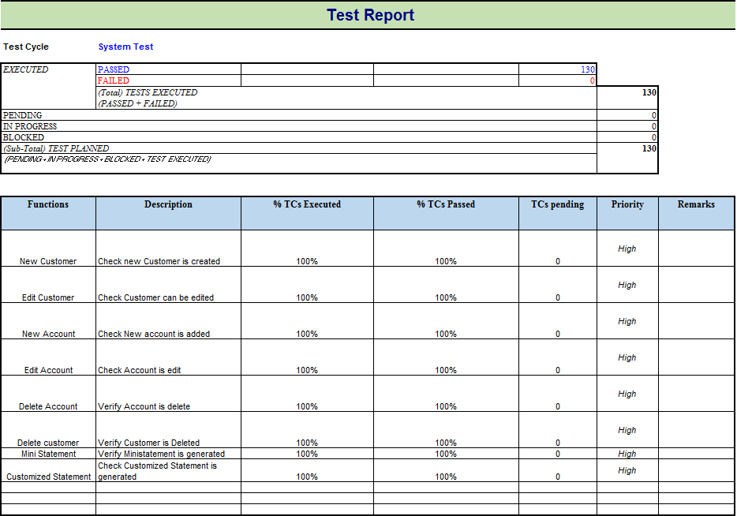
Template 2:
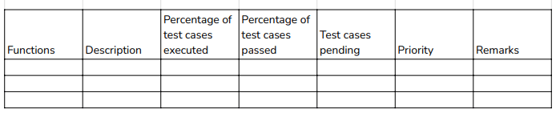
What are the Steps in the Test Reporting Phase?
Here are the steps in the test reporting phase:
- Collecting and analyzing test results.
- Preparing comprehensive test reports.
- Reviewing test reports and identifying defects.
- Prioritizing and assigning defects to developers for resolution.
- Verifying defect fixes.
- Re-testing defects.
- Tracking and reporting progress on defect resolution.
- Analyzing and reporting on overall test results.
- Preparing final test reports for stakeholders.

What Should a Test Report Include?
A test report should include the following key components:
- Introduction
  - Purpose: State why the test report is being created.
  - Scope: Define what was tested, including types of testing conducted.
  - Software Information: Detail the software tested, including version.
- Test Environment
  - Hardware: List hardware used, like servers and devices.
  - Software: Enumerate software components involved, such as operating systems.
  - Configurations: Detail configurations used in testing.
  - Software Versions: Mention versions of the software being tested.
- Test Execution Summary
  - Total Test Cases: Number of test cases planned.
  - Executed Test Cases: Number of test cases executed.
  - Passed Test Cases: Number of successful test cases.
  - Failed Test Cases: Number and explanation of failed test cases.
- Detailed Test Results
  - Test Case ID and Description: Include the test case's ID and a brief description for each test case.
  - Test Case Status: Status of each test case (passed, failed, etc.).
  - Defects: Details of defects found.
  - Test Data and Attachments: Include specific data and relevant screenshots or attachments.
- Defect Summary
  - Total Defects: Count of defects found.
One of the most important information in Test Report is defect. The report should contain following information
- Total number of bugs
- Status of bugs (open, closed, responding)
- Number of bugs open, resolved, closed
- Breakdown by severity and priority
  - Defect Categories: Classification of defects by severity and priority.
  - Defect Status: Current status of each defect.
  - Defect Resolution: Information on defect resolution.
- Test Coverage
  - Functional Areas Tested: Areas or modules tested.
  - Code Coverage Percentage: Percentage of code tested.
  - Test Types: Types of testing performed.
  - Uncovered Areas: Uncovered aspects of the software and reasons.
- Conclusion and Recommendations
  - Testing Outcomes Summary: Recap of main results.
  - Testing Objectives Met: Assessment of whether objectives were achieved.
  - Improvement Areas: Areas for improvement based on findings.
  - Recommendations: Actionable suggestions for enhancing software quality.
What are the Different Types of Test Reports?
The different types of test reports in software testing are:
- Test Summary Report: This report provides a high-level overview of the entire testing process. It summarizes the objectives, methodologies, and overall results of the testing activities, including any outstanding issues.
- Defect Report: This report focuses specifically on the defects found during testing. It details each defect's severity, impact, and status (open, closed, in progress).
- Test Execution Report: This report gives a detailed account of the test cases executed during the testing phase. It includes information on the number of test cases passed, failed, and skipped, along with specific details on the execution of each test case.
- Test Coverage Report: This report assesses the extent of testing coverage. It shows which parts of the software were tested and to what extent. It also highlights any areas that may have been missed.
How is the Test Environment Detailed in a Test Report?
Detailing the test environment in a report is vital for understanding- "How testing was conducted?" It should include hardware specifications, software versions, and configurations used during testing.

EXTRAS
Advantages of Test Report in Software Testing
A test report in software testing is a useful artifact and tool for both the QA team and all stakeholders for several reasons:
- It provides information about the quality status and readiness of the software application to both the internal team and external stakeholders (such as developers, project managers, and product owners). Especially available reporting promotes transparency between teams, where everyone can see the current status of the project and also they together might perform root cause analysis of specific bugs.
- A good test report includes metrics that help the QA team know the work’s effectiveness. Visualizing these metrics offers valuable insights for shaping future testing strategies and uncovering areas for future improvements.
- Test reports are usually aligned with the test plan, so they are critical issues for monitoring the overall progress.
- Test report verifies that the product complies with established requirements and standards.
Types of Testing Report Protocols
There are different types of test reports, each containing important information and key metrics about the tests performed:
- General Test Report. Provides a general overview of all test activities performed during a specific project phase or cycle. This report reflects metrics such as the number of test cases: successful and failed, as well as unresolved defects, helping participants in the testing project assess the overall state of testing. You understood right, it consists of different more detailed parts, which we consider at the bottom.
- Test Execution Report (TER). This report provides detailed information about each test, such as the test case ID, description, status of each test case (pass/fail), and any additional notes from the tester. It helps track testing progress and highlights areas that may require urgent attention.
- Bug Report/Error Report. Contains details of any bugs found, such as their identifier, description, severity, priority, reproduction instructions, and current status (e.g., open, fixed, closed). Bug report helps prioritize fixes and track progress in fixing bugs.
- Traceability Matrix. An RTM table that shows how each project requirement maps to a test case, ensuring complete functional coverage and demonstrating the test coverage achieved.
- Smoke Test Report. It verifies the critical App’s functionalities after the latest build deployment.
- Performance Report. Evaluates the results of performance testing, including response time, throughput, utilization, resource allocation, and scalability, thereby assessing system performance under various loads and identifying potential performance issues.
- Security Report. Describes the results of security testing, including discovered vulnerabilities and recommendations for improving security, especially for applications that handle sensitive information.
- Regression Testing Report. Summarizes the results of regression tests, evaluating the impact of new features on existing functionality and showing how changes have affected the system’s stability. Build such report with testomat.io using a @tags, labels and filtering features for test selection.
- Compliance Report. In regulated industries, such as finance or healthcare, these reports confirm adherence to relevant standards and may be required for certification.
- User Acceptance Test (UAT) Report. Includes the results of testing by end-users who evaluate whether the product meets their needs. The report captures user experience, identifies issues, and assesses the readiness of the software for deployment.

What Main Components of Test Report in Software Testing?
Of course, creating a good test report requires a systematic approach that includes several important sections. Each section has a specific purpose and contributes to its completeness.
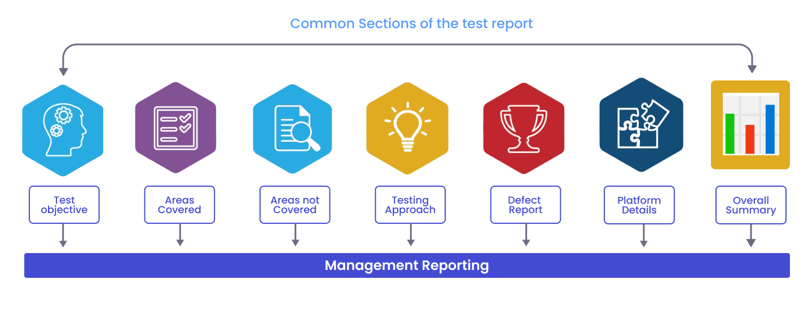
EXTRAS
Guide to Writing an Effective Test Summary Report
Step #1: Purpose of the Document
<Short description of the objective of preparing the document>
For example, this document explains the various activities performed as part of the Testing of the ‘ABCD Transport System’ application.
Step #2: Application Overview
<Brief description of the application tested>
For Example, ‘ABCD Transport System’ is a web-based bus ticket booking application. Online facilities allow booking tickets for different busses. The ‘Central Repository System’ provides real-time passenger information, which is consulted before confirming bookings.
There are several modules like Registration, Booking, Payment, and Reports which are integrated to fulfill the purpose.
Step #3: Testing Scope
- In Scope
- Out of Scope
- Items not tested
<This section explains the functions/modules in scope & out of scope for testing. Any items that are not tested due to any constraints/dependencies/restrictions>
For example, testing a functionality verification that requires connectivity to a third-party application is not possible due to technical limitations preventing the establishment of connectivity. If this section isn’t documented, it will be assumed that testing covered everything in the application.
- In-Scope: Functional Testing for the following modules is in the Scope of Testing
  - Registration
  - Booking
  - Payment
- Out of Scope: Performance Testing was not done for this application.
- Items not tested: Verification of connectivity with the third-party system ‘Central repository system’ was not tested, as the connectivity could not be established due to some technical limitations. The team can verify this during UAT (User Acceptance Testing) when connectivity is available or can be established.
Step #4: Metrics
<Metrics will help us to understand the test execution results, the status of test cases & defects, etc. Required Metrics can be added as necessary. Example: Defect Summary-Severity wise; Defect Distribution-Function/Module wise; Defect Aging etc. Charts/Graphs can be attached for better visual representation>
- No. of test cases planned vs executed
- No. of test cases passed/failed
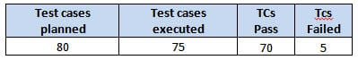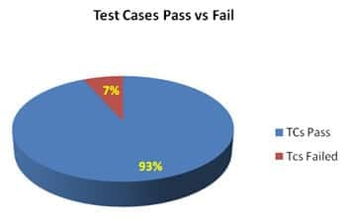
- Total defects detected, including their Status and Severity.
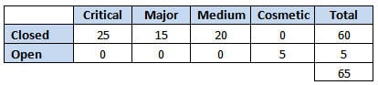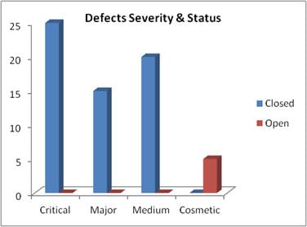
- Defects Distribution – Module Wise
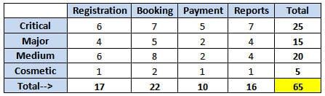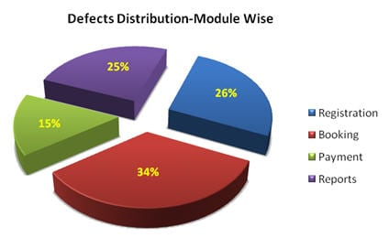
Step #5: Types of Testing Performed
- Smoke Testing
- System Integration Testing
- Regression Testing
<Describe the various testing performed for the project. This will ensure the application is being tested properly through the testing types agreed upon as per the Test Strategy. If several rounds of testing were done, the details can also be included here.>
For Example,
a) Smoke Testing
Upon receiving a Build and deploying it into the Test environment, testing is promptly conducted to confirm the functioning of essential functionalities, allowing the Build to be accepted and Testing to commence.
b) System Integration Testing
- The testing conducted on the application is to validate its adherence to the requirements.
- Testing is conducted in critical business scenarios to ensure error-free operation of key functionalities in the application.
c) Regression Testing
- Regression testing is performed each time a new build is deployed for testing, which contains defect fixes and new enhancements, if any.
- Regression Testing is done on the entire application, not just the new functionality and Defect fixes.
- This testing guarantees that the existing functionality remains intact after fixing defects and adding new enhancements to the application.
- Test cases for the new functionality are added to the existing test cases and executed.
Step #6: Test Environment & Tools
<Provide details on the Test Environment in which the Testing is carried out. Server, Database, Application URL, etc. If any tools were used like Quality Center (now HP ALM) for logging defects>
For Example,
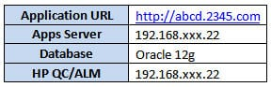
Step #7: Lessons Learned
<This section is used to describe the critical issues faced and their solutions (how they were solved during the Testing). Lessons learned will help to make proactive decisions during the next Testing engagement, by avoiding these mistakes or finding a suitable workaround>
For Example,
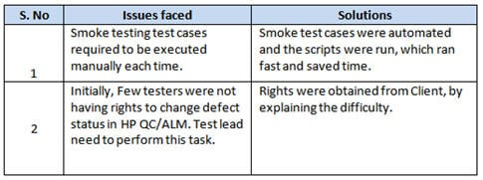
Step #8: Recommendations
<Any workaround or suggestions can be mentioned here>
For Example,
- Admin control for defect management tools can be given to the Offshore Test manager to provide access to the Testing team.
- Each time the onsite Admin does not need to be contacted for requests whenever they arise, saving time due to the geographical time zone difference.
Step #9: Best Practices
<There will be a lot of activities done by the testing team during the project. Some of them could have saved time, some proved to be a good & efficient way to work, etc. These can be documented as a ‘Value Add’ to showcase to the Stakeholders>
For Example,
- A repetitive task done manually every time was time-consuming. This task was automated by creating scripts and running each time, which saved time and resources.
- Smoke test cases were automated, and the scripts were run, which ran fast and saved time.
- Automation scripts were prepared to create new customers, where a lot of records need to be created for Testing.
- Business-critical scenarios are separately tested on the entire application, which is vital to certify they work fine.
Step #10: Exit Criteria
For Example,
- All test cases should be executed – Yes
- All defects in Critical, Major, and Medium severity should be verified and closed – Yes.
- Any open defects in the Trivial severity – Action plan prepared with expected dates of closure.
No Severity1 defects should be ‘OPEN’; Only 2 Severity2 defects should be ‘OPEN’; Only 4 Severity3 defects should be ‘OPEN’. Note: This may vary from project to project. Plan of Action for the Open defects should be clearly mentioned with details on when & how they will be addressed and closed.>
Step #11: Conclusion/Sign Off
<This section will mention whether or not the Testing team agrees and gives a green signal for the application to ‘Go Live’ or not after the Exit Criteria is met.
If the application does not meet the Exit Criteria, then it can be mentioned as – “The application is not suggested to ‘Go Live’. It will be left with the decision of Senior Management and Client and other Stakeholders involved to take the call on whether the application can ‘Go Live’ or not.>
For Example, as the Exit criteria were met and satisfied as mentioned in Section 10, this application is suggested to ‘Go Live’ by the Testing team. Appropriate User/Business acceptance testing should be performed before ‘Go Live’.
Step #12: Definitions, Acronyms, and Abbreviations
<This section mentions the meanings of abbreviated terms used in this document and any other new definitions>
=> Download Sample Test Summary Report:
Click here to download a sample Test Report template with an example.
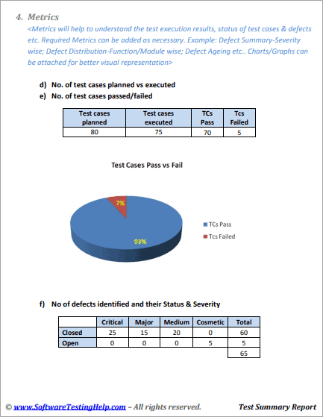
Few Points To Note While Preparing The Test Summary Report
- As part of the Test Execution, collect all the required information on the Testing performed. This will help prepare a sound test summary report.
- Lessons learned can be explained, which will convey the responsibility that was taken to solve these issues. This will also be a reference for upcoming projects to avoid these.
- Similarly, mentioning the Best Practices will portray the efforts taken by the team apart from regular testing, which will also be treated as a “Value Addition”.
- Mentioning the Metrics in graphics form (Charts, Graphs) will be a good way to visually represent the status & data.
- Remember, the Test summary report shall mention and explain the activities performed as part of the Testing to the recipients to understand better.
- A few more appropriate sections can be added if required.

